# Digital Streaming

## Definition:

**# Source**: **Chatgpt (GPT-5-Standard) at [10/26/2025]**  
**Digital Streaming** is a modern method of **playing music or videos directly online in real time** — without downloading the file.  
It allows users to **instantly access songs, albums, or performances** through the internet on platforms such as **Spotify** or **YouTube**.

## 🎶 Key Features:

**# Source**: **Chatgpt (GPT-5-Standard) at [10/26/2025]**

* Delivers **audio or video content** over the internet.
* Users can **listen or watch instantly** without saving the file.
* Available on **phones, computers, smart TVs, and tablets**.
* Includes both **music streaming platforms** (audio-focused) and **video streaming platforms** (visual + audio).
* Offers **on-demand access** — play anything, anytime, anywhere.

## 🎵 Examples:

**# Source**: **Chatgpt (GPT-5-Standard) at [10/26/2025]**

* **Spotify** – for streaming songs and podcasts (audio).
* **YouTube** – for streaming music videos and performances (video).
* **Apple Music**, **Amazon Music**, **TikTok**, etc.

## 🧭 In Short:

**# Source**: **Chatgpt (GPT-5-Standard) at [10/26/2025]**

**Digital Streaming** = Listening to or watching **music and videos directly online**, through platforms like **Spotify** or **YouTube**, **without downloading** — offering **instant, on-demand access** to media content.

## Differences Between Digital Streaming, Audio Streaming Platforms, and Online Video Platforms

**# Source**: **Chatgpt (GPT-5-Standard) at [10/26/2025]**

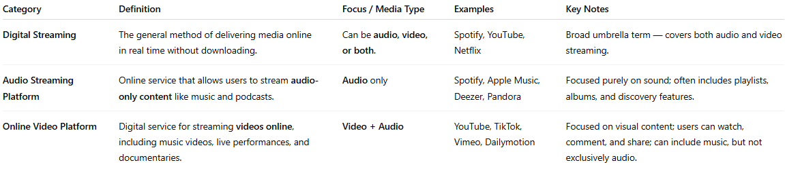

| **Category** | **Definition** | **Focus / Media Type** | **Examples** | **Key Notes** |
| --- | --- | --- | --- | --- |
| **Digital Streaming** | The general method of delivering media online in real time without downloading. | Can be **audio, video, or both**. | Spotify, YouTube, Netflix | Broad umbrella term — covers both audio and video streaming. |
| **Audio Streaming Platform** | Online service that allows users to stream **audio-only content** like music and podcasts. | **Audio** only | Spotify, Apple Music, Deezer, Pandora | Focused purely on sound; often includes playlists, albums, and discovery features. |
| **Online Video Platform** | Digital service for streaming **videos online**, including music videos, live performances, and documentaries. | **Video + Audio** | YouTube, TikTok, Vimeo, Dailymotion | Focused on visual content; users can watch, comment, and share; can include music, but not exclusively audio. |

**🧭 In Short:**

* **Digital Streaming** = **Broad term** for streaming any media online (audio or video).
* **Audio Streaming Platform** = Subset of digital streaming **focused on audio content only**.
* **Online Video Platform** = Subset of digital streaming **focused on video content**, which may include music.

💡 **Tip:** Think of it like layers:

**Digital Streaming (big umbrella)** → Audio Streaming Platforms (audio) + Online Video Platforms (video)